The United States Volunteer Rangers

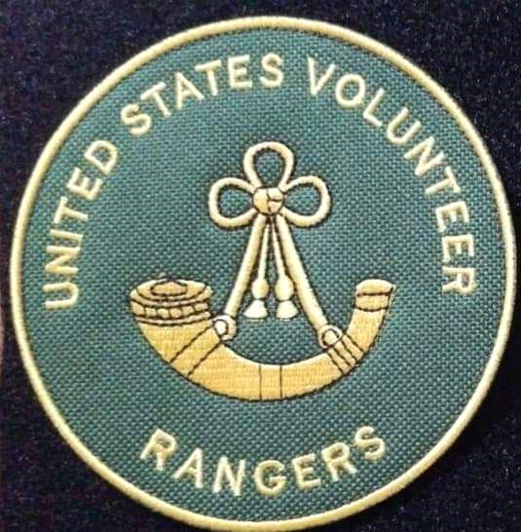

Membership Handbook

Book 1: Foundation and Basic Structure

Welcome to the United States Volunteer Rangers! The Scouting Organization for the 21st Century!

First lets talk a little about what the USVR is!

First and foremost, we are a scouting organization. We strive to continue the ideals of the scouting movement as it was intended when it was founded. The Ideals of Baden Powell and other originators of the scouting movement and what they envisioned. We combine that with the thought process of Major Robert Rogers and Captain Benjamin Church who founded the first Ranger units in North America long before the United States even existed. The idea of the fighting woodsman. In our case this means taking our passion for the outdoors, hunting, camping, bushcraft etc and putting it to good use in service to our community!

We encourage youth and adult outdoors skills, preparedness, citizenship, and character building through a program of events, camping trips, adventures and training within a structure that allows for achievement recognition and skill building. What all that means is that as you attain skill levels within the organization, you will be recognized for those achievements and with each achievement, you advance in rank and opportunity within the organization.

***Scouting the Ranger Way***

The United States Volunteer Rangers is a Family Based scouting organization. What does that mean? It means that unlike other scouting organizations, we do not specify that we are a youth organization, or an adults only organization. We do not specify what sex or orientation is catered to. Instead, this organization welcomes the entire family. Boys , Girls Men and Women, Non Binary, all are welcome and we encourage families to join together. The goal is that all family members share in the adventure! YOU BELONG!

The scouting movement was originally intended to educate youth in the skills and philosophy of self reliance through wilderness education and civic responsibility. As time has gone by, the Scouting movement became mired in religion and politics as well as attempts to “Change with the Times” . This resulted in them removing, and or heavily modifying scouting activities that are the core of what Scouting is all about. USVR attempts to bring back these important skills and activities through a program of wilderness education including camping skills, hunting, fishing, trapping and responsible use of firearms.

We also encourage “Skinned Knees”! By this we mean we encourage youth and adults to actually go out and have adventures, do amazing things like rock climbing, marksmanship, sailing, canoe and rafting trips and many other activities that other scouting organizations deem “too dangerous” or “Not politically correct”.

Liberty Minded Direction:

The USVR encourages independence and personal responsibility. We espouse to the idea that YOU are the best person to decide what goes on in your life.

We believe that by learning to be self sufficient, people will be less dependent on outside entities to keep them happy, healthy and safe. Likewise it will encourage our future leaders to move toward less invasive, more liberty minded government on the local, state and federal level. This also extends to our philosophy of inclusion. While we do not claim any affiliation with any cause, we do however,attempt to provide a welcoming atmosphere for anyone who wishes to enjoy the outdoors, help their community and be a member of this organization.

Leadership Skills:

The USVR helps its members become better leaders by encouraging them to always be students and sometimes be teachers. Everyone in the organization has the opportunity to develop the talent to step to the front, keep charging and encourage others to come along for the ride! We do this through our locally based leadership. Each family and friend circle is its own Team and they can develop into their own unique brand of Ranger.

Lets start where you start: Basic Membership.

When you join the United States Volunteer Rangers, you are at the basic Scout Level. This goes for Youth and Senior Membership. This means that advancement is the same regardless of age. In fact, as a family based scouting organization, we encourage the entire family to take part! So father, daughter, mother and son can all take part and share in the adventure!

Basic membership opens you up to all the general training and camping events your local post offers. As a basic member, you are asked to provide camping gear, tools and simple uniforms to continue attendance. Of course we don't expect it all overnight and most posts have some basic gear you can borrow and learn with.

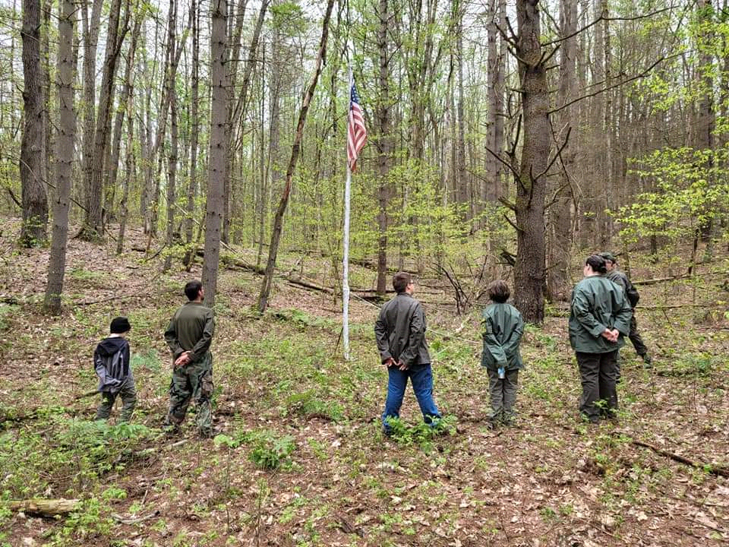

***Starting a Team:***

The Team is the basic level of the USVR. It consists of 4 or more members who get together regularly to do "Ranger Stuff". The Team can be, and often is composed of a family or a couple families, alternatly it can be a friend circle or even a group founded within a business where the employees make up the team!

The basic team can be set up anywhere and while it does not require a charter, must be recognized by the National Leadership. That recognition would include your Team name and general location being listed on the web site so others in your area interested in the Rangers can find you. The Team Leader should provide an email address to National to allow folks to contact them and will help in organizing trips, meeetings etc.

***Requirements for Team Formation and Maintenance.***

To be a recognized Team in the United States Volunteer Rangers, you must follow the basic rules for uniform, conduct and activities of the USVR.

* Your members must be in uniform for all activities. The Uniform can be found in this book under the heading of Basic Uniform. Also, examples can be found on the web site.
* You must show activity with at least 6 events, meetings etc per year that include outdoor activities, training, camping, Emergency Services.
* You must have at least four paid members
* You must Log into the Zello Comms Check for Leaders at 1930hrs EST the third Thursday of every month.

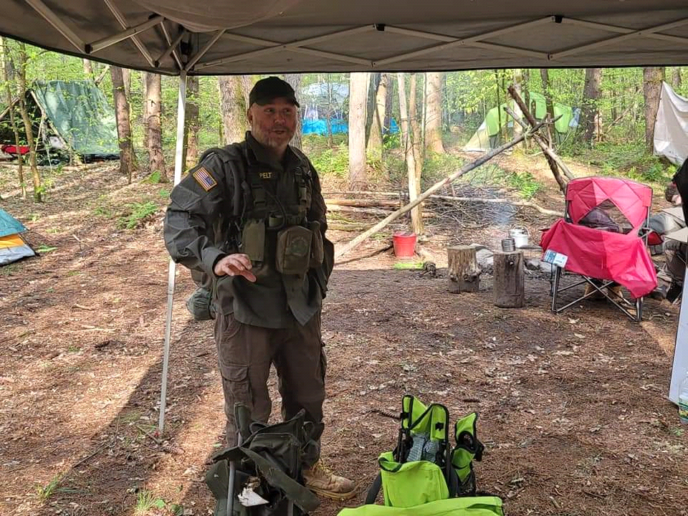

***Starting a Post:***

Often, there is not a local post nearby, and starting one is not too hard. We put this here so that you know that if you are just starting within the organization, you can help grow it at the same time! To start a post, you must first ascertain whether there is a post near you. If there is none, here are the steps:

* be a paid member of the United States Volunteer Rangers
* Start a Team and fulfill all requirements for Team formation
* Contact USVR National HQ and let us know you are forming a team in your area.
* Go Camping, Do volunteer work, all the things you want to do anyway as part of the Rangers. Do it in Uniform, and document your meetings, training and other events with photos, videos etc.
* Show activity for 6 months and Submit your Charter along with your paid membership list. You should at this point, show the following Post Officer positions being filled: Post Commander, Sargent At Arms, Treasurer and Training Coordinator. An Emergency Services Coordinator is also reccomended but can be rolled into the Training Coordinators position.

Once you have done these things, submit your application, application fee and documentation to National Headquarters (Address found on the back of this booklet) your charter will be shipped to you. Once you are a Chartered Post, you will be given a post number which you can put on your uniform in patch form.

Activities within the Rangers

As a member of the Rangers, you have the opportunity to be involved in lots of fun and gain knowledge in tons of valuable fields! The following are the staples of our organization but these are not exclusive! Your Post or Chapter may have opportunities specific to your area!

Camping and Hiking: All chapters and posts are required to hold monthly or bi-monthly trainings, drills and activities and one of the major activities is camping and hiking. We are a preparedness organization amongst other things and to be prepared is to be independent. Camping and Hiking teach us how to live with less and be happy! It teaches us what we really need to stay alive and well in adverse conditions. Its also an ton of fun! Our camping trips range from events on private property to long distance backpacking trips (And everything in between!) Smores and Stories around the camp fire, camp crafts and projects as well as primitive camping and bushcraft are a huge aspect of our time spent in the woods.

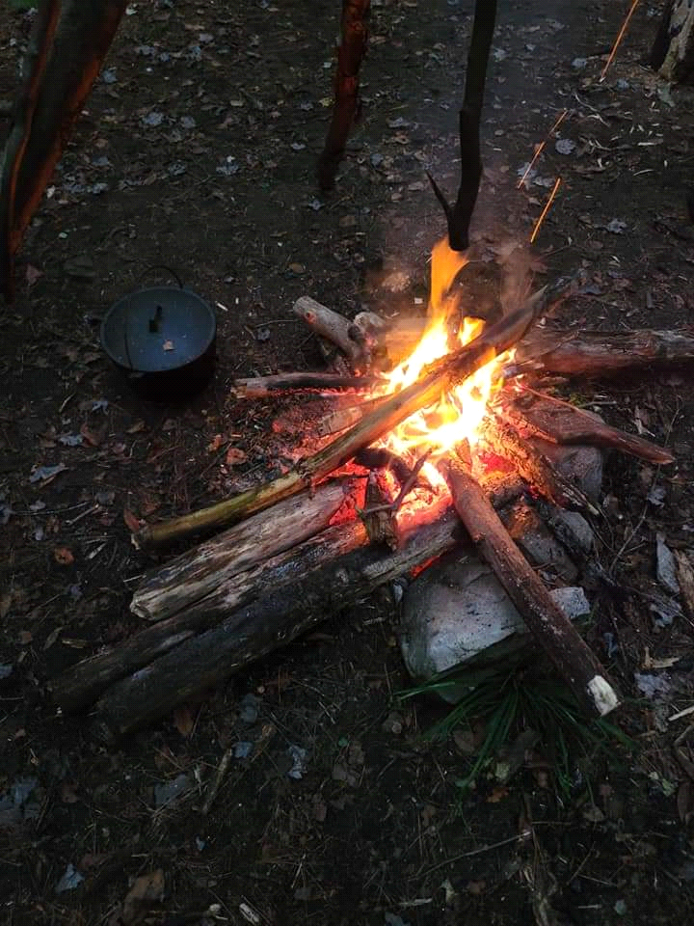

***Hunting and Fishing***: Many Posts will organize fishing and hunting trips and usually there is a large pool of experience to share for new hunters and anglers! If you are new to these activities, we are a great place to get the training Hunter Safety Courses, Fishing Derbies and YouTube just cant provide! Of course, group buys on gear, lures, ammunition and safety training are options we can take advantage of!

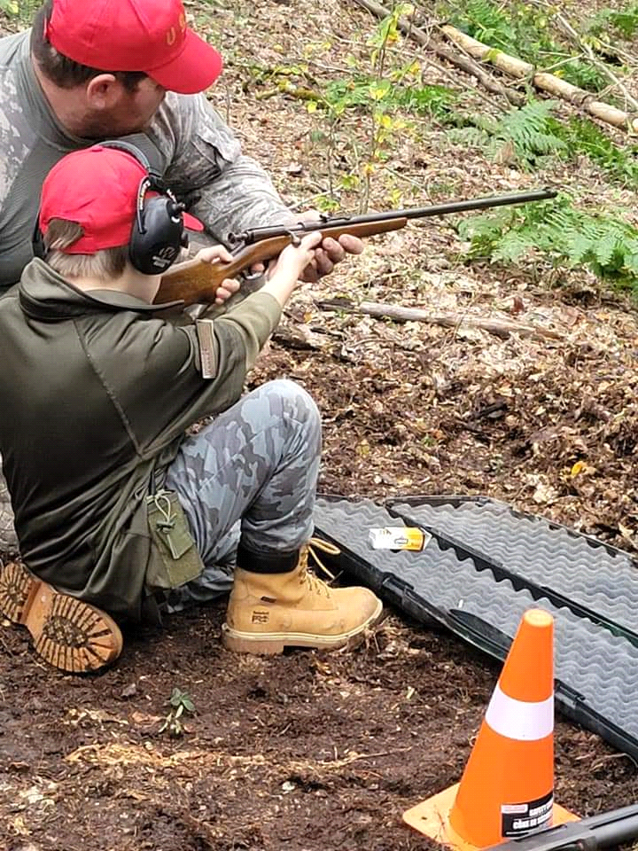

***Marksmanship***: Rifle Marksmanship is part of the Ranger legacy and an integral part of our nations defense. We encourage marksmanship training and firearms safety as part of our regular activities. The safe and effective handling of firearms is focused on both at the Youth and Senior level. Most of our Marksmanship activities are done with .22 caliber rifles, or Air Rifles as they are a great way to become proficient and stay on budget. Higher caliber rifles are an option as well but this depends on range safety requirements and local laws. We also train in defensive shotgun as part of the preparedness and emergency services aspect of our organization.

Preparedness: One of the cornerstones of the Scouting movement is preparedness. We focus on this aspect both on the individual, family and community level. USVR holds classes in food preservation, water purification, alternative power and lighting and much more! Posts and Teams within our organization can and often do act as "Preparedness Groups" and work together to become better prepared for disasters, help each other in times of need as well as sharing and learning skills together!

Emergency Services

Our organization is intent on the ability to use the skills we gain to the service of our community and nation. We do this through a program of disaster response. For more information on emergency services, see the Emergency Services Handbook.

HAM Radio:

The USVR is a huge proponant of Amature Radio and its responsible use both for recreation and as a tool to communicate during emergency situations. We encourage all our members to attend a HAM Radio class and become licenced HAM Radio operators!

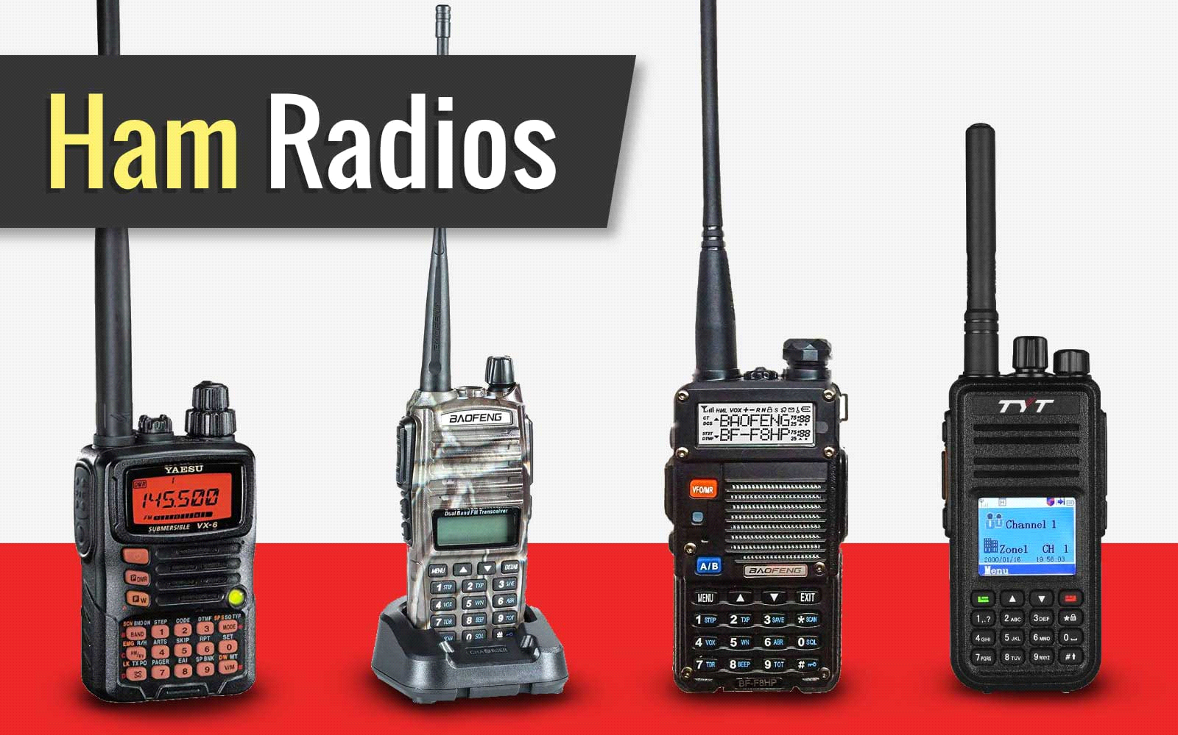

Ranger Customs and Courtesies

The United States Volunteer Rangers is rich in customs and ceremonies to mark important milestones and to go about the business of being an organization. The following are some of the customs of the Rangers as well as descriptions of the ceremonies we follow as part of the spirit of the scouting and ranger movement!

The Ranger Moot.

This happens at every major gathering of the Rangers from Post level up to National level events.

The moot is run as follows:

A council fire is constructed with logs cut by all members and is stacked, log cabin style at least hip high, but may be as high as shoulder high. The inside of the the “cabin is filled with tightly packed kindling and tinder. Tamp it down with a log. A tipi fire is constructed on top so that the fire burns down through the cabin.

A large log is prepared by the members and is designated as the speaking stump. A special, large stump can be brought in for the purpose and the sides can be decorated as this stump will be used for a long time.

The membership designates a fire keeper. This person is first into the Council Fire Circle and lights the fire, torches and so on. The next to enter the circle is the color guard. The color guard consists of at least two members, one carrieing the national colors, either folded for erection on a pre-made flag pole or posted on a stand. If the unit has USVR colors, these will also be carried in at this time. The guard will also consist of at least one guardsman or guardswoman who is armed with a sword, spontoon, spear or rifle with bayonet. If the post has none of these, a tomahawk will suffice.

Posting the Colors:

At the beginning of every USVR event, we post colors. This is done to signify the beginning of the days events.

This is also called "Opening Formation" At this time all members form column facing the flag pole or flag stands, with the Commanding officer at the head of the formation, the Executive Officer stands to the right and slightly behind the CO and Sgt-at-Arms (SAA) acts as the element leader and stands next to the right guide of the formation.

the Sgt-at-Arms steps to the front, does an about face, to face the formation:

The SAA Calls the formation to attention and then calls: "Attention To Orders! Orders of the Day, Officer of the Day is Ranger (Rank) __________________, Orders of the Day: lists posted events or general outline for days events. Performs a roll call based on active member list for the Post. Notes new members, visitors. when finished, performs an about face and states: Sir/Ma'am , # Rangers present and accounted for! Notes to C/O any sick calls, and salutes. C/O salutes and orders "Post Colors"

At this point color guard Approaches, Armed color guard members take position to right and left (right if only one is present) The Color Barer presents the flag and the SAA Accepts the National Colors and begins to attach it to the staff. Once attached, the SAA steps back and blows the Bosun Whistle as the Color bearer hoists the Colors. If the state or Unit flags are to be attached as well, they will be attached and then all hoisted together with National Colors, State Flag, and USVR Colors hoisted in that order.

For the Purposes of the USVR, Posting the Colors entails one of two things. If inside a building, it may simply be placing uncased parade flags in their stands. if outdoors, and a flag pole is available (in permanent camps, this is one of the first fixtures you install at the council fire area.)

The Color Guard will carry the national, and organizational colors (If available).

They will enter from the right and around the council fire. If a flag pole is present, the folded flag will be attached, along with unit colors if available.

Declaring the Council:

The highest ranking member of the organization steps forward and firmly sets their tomahawk in the speaking stump. This person will then say: By right of deed and by your word, I bring this council to order, and by the creator and the four winds I open the council. Ranger _______________ is the Council Leader, Ranger ______________ is the fire keeper and Ranger __________________ is the Guardian. Let all who speak here do so with truth, honor, and respect.

This person then removes their tomahawk from the speaking stump, slides it into its place on their belt and goes back to their place in the circle.

The so named Council Leader steps forward and holding their tomahawk, points to the first to speak. The person adressed comes forward and places their tomahawk in the speaking stump. once they have said their peace, or performed their wisdom, they remove their tomahawk and return to the circle. Each subsequent speaker repeats the process.

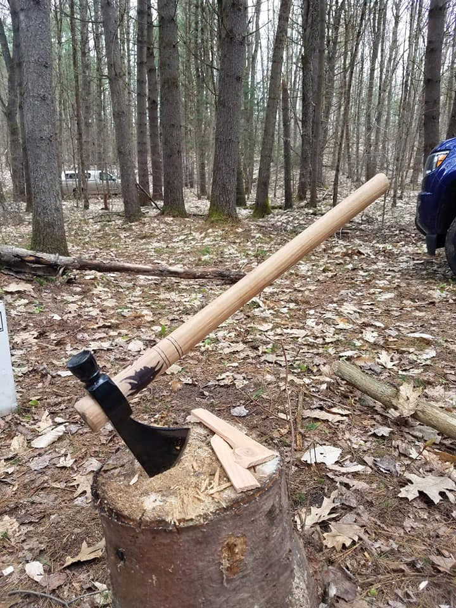

When the council is done, the Council Leader approaches the speaking stump and sets his hawk in the stump. The leader then declares the following:

" The Fire Burns Low! The Hour is Late and All have Said what needed to be said. Go now in Peace and Wisdom!

It is at this point that the fire is doused by the fire keeper, all who are there stand. The color guard leaving first

Indoors, the Council Fire is replaced by a kerosene lantern set aside for the purpose.

**Making a Ranger:**

Making an Ranger is the presentation of a Scout who has performed all tasks necessary to become a Ranger. This is done as a Moot. A moot is an official meeting done at council fire.

The Scout is presented by a sponsoring Ranger that attests to their completion of all of the required achievements necessary to be made a full Ranger. They also attest to the scouts good character and dedication to the Volunteer Ranger Service.

The Scout is called "Front and Center" and will make their way to the front of the assembled members. They will raise their right hand and swear or attest the Ranger Oath.

* I ________________ swear/attest to protect and defend the constitution of the United States, from all threats, foreign and domestic.
* I will serve my community during times of strife.
* I will defend the helpless
* I will speak the truth
* I will be prepared both at home, in my community and upon my person at all times to the best of my ability.
* I will take no action that will place the United States Volunteer Rangers in jeopardy , or place its reputation in a bad light.
* I will not disrespect my fellow Rangers.
* I will do my best in all my endeavors, in accordance with my faith/philosophy.

The Scout is asked to present their tomahawk to the officiating officer. It will be inspected for sharpness, safety and uniqueness of decoration. The Officer will then set the scouts tomahawk in the speaking stump. Next the Scouts Uniform will be inspected, insuring all patches are in the right places and that the uniform is in good order.

It is at this time that the scout is presented with the Ranger Bonnet. The New Ranger will then be instructed to retrieve their tomahawk and return to the formation.

***Titles, Awards,Ranks and Officials***

Officials:

The United States Volunteer Rangers is run by a loose military model. You will notice some military type ranks as well as some ranks that are very different! It should be noted that holding rank means you are DOING something. Very few ranks are achieved because of time in service or by taking a test.

National Commander:

The National Commander holds the rank of Major or Lieutenant Colonel. These ranks are held only by the national commander and are ceremonial in nature as these are the ranks held by Robert Rogers, the founder of Rogers Rangers.

The National Commander is the titular head of the United States Volunteer Rangers. They are chosen from among the state commanders as needed and hold the position until they decide otherwise or are deemed no longer able to perform their duties.

Duties of the National Commander:

* Final say on promotions to State Commanders
* Represents the organization to other scouting and emergency services organizations.
* Final say on Charters for State Chapters.
* Approves funding on the national level
* Approves Changes to this document.

Deputy National Commander:

The Deputy National Commander (DNC) Holds the rank of Captain and works closely with the National Commander to run the general operations of the organization. The DNC certifies all national level positions and oversees their operations.

Duties of the DNC:

* Insures that all national level positions are filled and that those filling them are qualified to hold those positions
* Coordinates with the National Commander and State Commanders during times of emergency.
* Approves all funding for National Level events
* Approves and oversees discipline and corrective regulations
* presides over and organizes the national command meeting

National Emergency Services Coordinator:

The National Emergency Services Coordinator (NESC) is responsible for all emergency services activities on the national level. They coordinate with NGO, Local, State and Federal officials to insure that USVR Manpower and Apparatus are utilized in accordance with the Mission commanders intent and the general orders of the USVR.

Duties:

* Set standards of training for all ES personnel in the USVR
* Coordinate with the State Quartermasters to keep an accurate accounting of all Emergency Apparatus available.
* Approve all State Emergency Services Chiefs
* Set standards for readiness for all facets of the emergency services aspect of USVR

National Signals Officer:

This officer will hold the rank of Lieutenant or Captain and is in charge of communications and public affairs within the USVR and coordinates with Public Affairs Officers and State Signals Officers. This person should have a background in communications and/or a HAM Radio license as well as be a qualified Emergency Services Ranger.

National Secretary: Position may be held by the DNC.

If this is a separate position, they do what the DNC does in regards to the National Command Meeting and any other Non-Emergency Services related jobs

National Scouting Leadership Coordinator:

Their job is to insure that each chapter is maintaining the primary missions of The United States Volunteer Rangers. They insure the vision of “creating stronger citizens, families and communities through a mission of outdoor skills, preparedness. leadership, good citizenship and self sufficiency. Scouting, Emergency Services, Preparedness.

Cadet National Commander: Acts as the National Youth Leadership Coordinator:

This position is held only by a Cadet Level Ranger and has the responsibility of ensuring that youth programs are planned and lead by the appropriate youth leaders.

*State Command (Chapter Command)*

Each State is designated as a chapter in the United States Volunteer Rangers. The Chapter can either be a Chartered Chapter or an Unchartered Chapter. The difference between the two is if the Posts within the organization elect to create a state level command structure and apply for a Chapter Charter.

**Unchartered Chapter:**

This type of chapter has no state level leadership and all Post Commanders report directly to National Headquarters.

Chartered Chapters: These chapters have the same leadership model as national headquarters. The Chapter Officers are voted on by the Post members Cadet Commanders or appointed by the State Commanders or their designated representatives.

In addition to the above positions, Chartered Chapters have the following chapter officers:

State Security Chief:

The State Security Chief has the responsibility of insuring all Patrol and Security Officers within the state have taken the USVR Basic Security and Patrol Class and have the required ES Card.

State Cadet Commander:

Must be held by a Cadet Level Ranger who has gained their bonnet. This officer coordinates with State and Post Commanders to ensure youth level programs are operating. This is a full chapter level officers position answering directly to the State Commander.

State Quartermaster:

The State Quartermaster reports to the DNC and the National Emergency Services Coordinator. Their job is to keep track of all USVR apparatus and equipment, receive inspection reports of said inventory and maintain a record of all inventory acquired and disposed of by the organization.

State Chief Medical Officer: This position is highly encouraged but not required. The CMO is responsible for regulating and insuring all medics within the organization have at least the minimum required equipment and credentials necessary to complete their mission. They insure that all medical equipment owned by, or deploying with the Chapter is maintained and appropriate to its intended purpose.

To receive a charter, a chapter must be able to prove that they have at least three active Posts and that all members are full paid members or associate members.

**Post Positions:**

Posts often have a very simplified version of the Chapter and National organizations. There can be chartered posts in unchartered chapters, but no unchartered posts, as they would just be a large team.

Post Commander: This person is the face of the Post and should be senior enough in the post to gain the respect of the members of that post. Post Commanders should have at least the Ranger Bonnet or higher in rank.

Post Secretary: Handles any and all business affairs of the post. deals with money, submits information to Chapter and National leadership and ensures the Post is up to date on regulations.

Post Sergeant at Arms: Handles the Ceremonies, Acts as the Security Coordinator for the Post and can step in as Acting Post Commander should the need arise. Also coordinates Emergency Services activities within the Post.

Post Training Coordinator: This position can be held by the Post Commander or any of the other positions, or can stand alone. This person ensures that members are recieving the training and experiences they are due as members of the Post. they coordinate both training and activities such as camping trips, classes, meetings etc.

Posy Cadet Leader:

Acts to organize Cadet Level activities within the post. Must ensure the same level of training is present on the Cadet Level, ensures youth programs and recreation are part of all appropriate events and advises the Post Commander on matters related to Cadet Level Membership.

Team Positions:

A Team is the simplest element of the USVR. When starting a Team, one only needs to designate a Team Leader. A larger team can elect to have some of the other positions listed above but it really isn't necessary. When Registering a team, the Team needs to show two things: It has a Team Leader, and a Team Name. For Example, if a team is stand alone in a new area, they can just call themselves USVR Team Anytown or USVR Gorilla Team (Anytown, NY) If they are a team in an area where a Post exists, they would be Gorilla Team, Team 32 Post 001. Of course these are examples and new teams can use any of these formats to create their own team name. Teams are welcome to create their own team patches, guidons etc. but must wear the standard uniform of the USVR.

Team Leader: Represents the Team and is point of contact for all business. If the Team leader has earned the Ranger Bonnet, they are a Senior Team Leader and may wear a gold ribbon or band around their bonnet or folded and stitched to the front chest flap of their uniform coat, in approximately the middle of the chest.

**Ranks within the Rangers:**

When you begin your journey through the ranks of the Rangers, you join as a Ranger Scout. Everyone starts out this way. The Scout ranks are your chance to get the very basic skills necessary to qualify as a Ranger and earn your Bonnet. Lets first talk about the Tomahawk Levels. The Tomahawk is the symbol of the Rangers, the tool and weapon traditionally associated with Rogers Rangers and spoken of often in Robert Rogers' Rangers Standing Orders:

*1. DON’T forget nothing.*

*2. HAVE your musket clean as a whistle, hatchet scoured, sixty rounds powder and ball, and be ready to march at a minute’s warning.*

*3. WHEN you’re on the march, act the way you would if you was sneaking up on a deer. See the enemy first.*

*4. TELL the truth about what you see and what you do. There is an army depending on us for correct information. You can lie all your please when you tell other folks about the Rangers, but don’t never lie to a Ranger or Officer.*

*5. DON’T never take a chance you don’t have to.*

*6. WHEN we’re on the march we march single file, far enough apart so one shot can’t go through two men.*

*7. IF we strike swamps, or soft ground, we spread out abreast so it’s hard to track us.*

*8. WHEN we march, we keep moving till dark, so as to give the enemy the least possible chance at us.*

*9. WHEN we camp, half the party stays awake while the other half sleeps.*

*10. IF we take prisoners, we keep ’em separate till we have had time to examine them, so they can’t cook up a story between ‘em.*

*11. DON’T ever march home the same way. Take a different route so you won’t be ambushed. 12. NO matter whether we travel in big parties or little ones, each party has to keep a scout 20 yards ahead, 20 yards on each flank, and 20 yards in the rear so the main body can’t be surprised and wiped out.*

*13. EVERY Night you’ll be told where to meet if surrounded by a superior force. Don’t sit down to eat without posting sentries.*

*14. DON’T sleep beyond dawn. Dawn’s when the French and Indians attack.*

*15. DON’T cross a river by a regular ford.*

*16. IF someone’s trailing you, make a circle, come back onto your own tracks, and ambush the folks that aim to ambush you.*

*17. DON’T stand up when the enemy’s coming against you. Kneel down, lie down, hide behind a tree. Let the enemy come till he’s almost close enough to touch, then let him have it and jump out and finish him up with your hatchet or cutlass*

As you can see, the Tomahawk or Hatchet is a very important part of a Rangers kit! It is a multi-purpose tool that allows a Ranger to do quite a lot in the field! For this reason, it is both ceremonial and functional part of of the Rangers Uniform. It also plays a part in the beginning ranks of the organization. One of the first pieces of kit youll be asked to procure is a tomahawk.

Red Tomahawk: This is your first rank! Wow you made it! When you gain your red tomahawk rank, it means you know the basics of camping and woodcraft. You have your kit sorted and you know how to use it! You have gone on a couple camping trips, made some fires, whittled with your knife, knocked up a debris hut and so much more, and I bet you had a heck of a lot of fun doing it! This is your bridge to every other activity within the Rangers. You have your Tomahawk, your Walking Stick and your knife. Emblem for this rank is a Red Tomahawk patch or a thin red cord around the arm or woven around the boonie hat band.

The basic equipment requirements for Red Tomahawk are listed in the section entitled Individual Equipment Requirements! You will notice that these requirements are very basic and more than likely you have most of the items listed. If so, that's great! If not, the items listed below will give you a good start and not be too expensive!

White Tomahawk: This Rank deals with service! It means you went out into the community and brought the Ranger Ethos to your volunteering and helping others! You helped out at Camp and assisted on projects that improved camp life for your fellow Rangers! Here you will qualify with many of the woods tools you will use, as well as basic marksmanship with rim fire rifle, air rifle or bow. You have the weapon and the ammunition for these. Emblem for this rank is a white tomahawk patch or a thin white cord around the arm or woven around the boonie hat band.

.

Blue Tomahawk: Okay, now you have some basic first aid skills! maybe you got your Red Cross or American Heart Assn. CPR and or First Aid, or attended basic first aid discussions within the Rangers! You have your individual first aid ki (IFAK)t and you know how to use everything in there! You made a splint, learned how to use a CAT Tourniquet and tons of other life saving skills! You are learning basic preparedness and have developed food storage, water and tools for home preparedness. You have a bug out (BOB) or get home home bag, and can carry it on the march. Emblem for this rank is a blue tomahawk patch or a thin blue cord around the arm or woven around the boonie hat band.

***Gold Tomahawk:***

This is a special award for Rangers that go above and beyond, making their own gear.

Also known as the John Glenn Wrubel Jr. Award, this is for those who show ingenuity in building and using handmade gear to satisfy the equipment requirements. A gold tomahawk patch is authorized for wear with this award

***THE RANGER BONNET***

Congratulations, you are now a Full Ranger! You have done your Ranger Challenges, shown skill in the use of Map and Compass, have shown leadership skills and of course you now have your full uniform and patches! Your have now gained the honor of wearing the Ranger Bonnet! Now to get on to the good stuff!

The following are the Ranger level ranks. they are denoted by chevrons pinned to the bonnet. They are named after famous Rangers of history who embody what being a Ranger is all about! Emblem for this rank is the Ranger Bonnet, and Gold Braid around the hat band

**General William O. Darby Award: (Apprentice Ranger)**: Your foundation is set well and you are now honing your skills! You are an experienced hiker, fully equipped for a day in the field. You are a decent marksman with rifle or bow, You are the person people ask when there’s a question at camp! Now its time to become better at woodcraft. Time to learn spark based fire making, primitive skills and more! (Single Chevron, on bonnet)

**Francis Marion "Swamp Fox" Award (Journeyman Ranger)**: You have good woodcraft and camping skills, now its time to head out for multi-day backpacking trips. You have a backpacking pack, and a good store of woodcraft to take you into the back of beyond! You might have already done much of what is required here but there is definitely more to know. You are now leading trips, supervising training and are a resource for many aspects of the organization. You may be part of the Emergency Services aspect of the Rangers. (Two Chevrons on Bonnet)

**Captain Benjamin Church (Master Ranger)**: You now hold the rank of Sergeant of Rangers. You have shown skill in woodcraft, camping, survival and preparedness and can teach those skills to others, you are confident, well equipped and capable. Now you turn to leadership roles in the Rangers. You teach classes both for members and the public and are trained and/or have certificates in basic first aid, CPR and other credentials (Three Chevrons on Bonnet)

**Major Robert Rogers Award (Ranger Chieftain)**: You are the pinnacle of what a Ranger of the USVR is! you have a vast knowledge across many fields of endeavor and can be depended upon to be there, at the front, whenever its needed. You have lots of time in service and regularly attend skill building classes both inside and outside the organization and your peers have deemed you qualified to attain this final rank. Does it mean you are done learning? That you are an expert? Nope..no such things. You are always learning, always teaching and there's always something new to know. Ox and Bucks Cap Badge or Patch if Available, if not, Gold Lt. Bar

You may also add a corresponding amount of feathers, tastefully added to the bonnet for the above ranks. This, however this is optional.

***Achievements:***

Achievements are awards anyone can earn based on their activities within the Rangers. They are named after famous rangers of history and fiction as well as noted outdoor figures who made an impact on modern outdoors philosophy.

The Ron Hood (Woodsmaster) Award: For Excellence in Survival Kit building and Use (Camping with Limited Equipment by choice! Especially using Contractor Trash Bags!!

The Nessmuk Award: For the prolific paddler (Canoe and Kayak Camping and Hunting

The Horace Kephart Award: For Long Distance Woodcraft trips and hikes (Primitive trekking and camping)

The Strider Award: Excellence in Hunting and Stealth camping skills

The Locksley Award: Excellence in Traditional Archery marksmanship.

The Karen Hood Award: For excellence in wilderness cooking and primitive outdoor cooking

The Ann LeBastille Award: Excellence in Homesteading and Self sufficient living skills.

The Rifleman Harris Award: For excellence in marksmanship.

The Marty Simon Award: For excellence in survival instruction.

All of these are presented as plaques but may have corresponding decorations in the future

***Symbols and Heraldry***

The United States Volunteer Rangers uses many different symbols and devices to be recognized and separate from other organizations. These are a just a few of the more prominent ones:

The Hunting Horn: The hunting horn, ever a symbol of the Rangers, Light Companies and Rifle Companies of many nations, is our most prominent device, being on all of our patches and flags. Our blazon is the following: A field Vert, A horn, with tied cord Or

The specific green is known as Bottle Green and the horn is the original cap badge of the Oxfordshire and Buckinghamshire Light Infantry, done in honor of that regiment who's lineage stretched back to the beginning of the concept of light infantry, rangers and many similar irregular units.

The Yellow or gold Hat Cord: Worn on wide brim hats to denote a qualified mounted Ranger. That is a Ranger qualified to ride a horse.

The Tomahawk: The weapon of the Ranger, in many colors shows up in our many ranks and tucked through our belts. This item is a mandatory piece of kit for each Ranger and serves both a ceremonial and functional purpose.

The whistle: a light infantry whistle can be seen on some of our officers, similar to those carried by officers and ncos during world war 1 and by police in the United Kingdom.

The Bosun Whistle: The symbol of the Sergeant at Arms. It is used for various ceremonies and to call assembly for Moots.

Tartan: Much of our traditions hearken back to the Scottish highlands including the use of the Highland Bonnet or Balmoral as our distinctive head ware , and some of us may choose to wear tartan in the form of the kilt (With class A uniform shirt or polo) or a swatch as a flashing on our bonnets. For this purpose, the official tartan pattern for use with our uniform is Black Stewart. Alternately a Ranger may wear a solid green or solid black kilt. "Utility Kilts" are acceptable so long as they are either the Solid Black Stewart, Solid OD Green or Solid Black Special dispensation can be made for unit patterns or for those who identify as a member of a specific Scottish Clan, Irish County or the National Tartan of their country of lineage. When used as flashing for a bonnet, members may use their own tartan pattern or one of their choosing.

Picture

***Fundraising and Marketing***

The ability of a team or post to gain the equipment and supplies needed can seem daunting! Between Uniforms, camping equipment, tools and supplies, there's a lot to do and in this day and age, money isn't always in abundance. This is where creativity and fundraising is key.

Types of fundraising:

Sponsorship:

Often times there are businesses in your local community that would be happy to lend a hand. Reaching out to these businesses can glean anything from funds, to even grants of equipment and supplies!

Bake Sales:

Yes, I know this is an obvious one but it does tend to glean funds in an easy way. All it takes is raw materials and the industrious nature of your Rangers and their family to provide the materials to sell.

Craft Sales:

Much of what we do involves crafting our own gear. Something as simple as making walking sticks, pouches and haversacks can be made and sold. Talk to your members, who knows what skills they have that they can teach and gain funds!

Of course this list is not exhaustive, its merely there to give you some ideas for raising funds. Use your imagination and think outside the box!

***Marketing and Recruiting:***

Marketing and Recruiting are hand in hand with the Rangers. If you want more opportunities and a larger pool of skills, being able to gain members and opportunities is very important. Now this subject can literally be made into a collage degree and we wont be going too deeply into it here. However, we can give some simple pointers to help you get started!

Fliers: Developing fliers to post at your local sporting goods store, public bulliton board etc is an easy way to get started. These fliers can be as simple as a hand made informational flier that is photocopied, to a full color one made with pictures! Use your imagination! Feel free to add the national web site (usvrangers.org) or the international web site (ivrangers.org) to help market your group and to drum up membership

***Basic Ranger Uniforms***

The standard uniform shirt (Standard Field Shirt) is the OD Green tactical coat with Velcro pockets on the shoulders such as the one below:

picture

This shirt allows members to add and remove patches from the shoulders to aid in identification. In addition, the standard tactical shirt is a very good shirt for wear in the outdoors! Its worn loose so as to allow for layering during colder times and for the sleeves to be rolled up during warmer times. At all times, the shirt should be tucked into the trousers

Here is a picture of one of our members wearing the standard Field Shirt:

Picture

**LIGHT FIELD SHIRT**

Also considered Standard Uniform is the Light Field Shirt. This an OD or Ranger Green Combat shirt such as the one below . These were originally designed to be worn under body armor and be tight in the torso. This is of course not necessary for our purposes so in order to be worn properly for , members must order the combat shirt (Light Field Shirt) in one to two sizes larger than their regular size to keep the shirt fitting loose. Further, the addition of Velcro strips for applying name tapes, or screen printed/stenciled lettering on the back is highly encouraged. At all times the shirt must be tucked into the trousers

Here is a Light Field Shirt being worn by one of our members:

Picture

**CLASS A and UNDRESS UNIFORM SHIRTS**

These uniform options are grouped together because they have very similar standards even though they have different purposes. The Class A shirt is found online at Police uniform outlets. It can be long or short sleeve and has a collar, two breast pockets and sewn-in military creases. The prescribed color is Border Green but Olive Drab is also authorized.

The Undress Uniform Shirt should be the same color but consists of a readily available store bought two pocket button down shirt in the above colors. It’s best to choose this shirt from the camping and fishing section as the Undress Uniform shirt is primarily for use in the field. The advantage of the Undress Uniform Shirt is availability even on secondary markets such as thrift shops. The shirts should be in good repair and both breast pockets must have flaps that either button down or use hook and loop to keep them closed. For both uniforms, they are marked the same way:

USVR Patch: This is stitched to the left shoulder, centered to the seam and

/or the epaulet approximately ½ inch below the shoulder seam. (a pinky finger width is an easy measure in a pinch! ) The American flag (Full color) or a specialty patch is similarly affixed to the left shoulder. A name tag or name tape sits atop the right breast pocket. Thatch left breast is left unadorned unless your either A) have specific achievements to add or B) have service ribbons or badges from other authorized organizations or prior military service.

The class A Field Shirt is worn for more dressy occasions and is generally considered a dress uniform, however, it is authorized for use in the field if you so choose.

Be sure to pick non Velcro patches when ordering for this uniform. Alternatively you may buy OD green hook side Velcro, affix your patch and cut the Velcro to the shape of the patch and apply to the Shirt in the same manner as above

Picture  
Undress Uniform Shirt:

Picture

Trousers:

Any OD Green outdoor trousers are authorized as well as OD Green shorts in hot climates. These should fit the wearer and at least have back pockets and front slash pockets. Cargo pockets on the legs are HIGHLY encouraged. No sagging or similar fashions allowed. OD Green BDU style pants are a great choice!

***Head Gear:***

Boonie Hat

The standard uniform headgear is the Boonie Hat or Bucket Hat in OD Green. This hat should fit the wearer and can be worn with the brim wide or tied up on the sides.

Picture:

Patrol Caps and Baseball Caps:

Alternatively members may choose to wear the patrol cap or unit specific baseball hat. It is up to the individual Post Commander to allow or disallow the wear of this head gear.

Picture

Picture

The Ranger Bonnet: this is the standard uniform for those who have earned the right to wear it! The Ranger Bonnet is authorized for wear in all uniforms and at all times. The standard Ranger Bonnet is Green with a black pompom. The adornment of this bonnet is up to the wearer but the USVR/IVRC cap badge ( Oxfordshire and Buckinghamshire Light Infantry Horn in yellow on a green field) is a great choice!

Picture

The Grey Bonnet: A Grey Bonnet with green pompom is authorized for wear by those who are in dress uniform or are doing community service. This is also the alternate Bonnet for those countries that reserve green bonnets for other organizations.

Footwear:

Many members choose to wear surplus combat and tactical boots, while others choose civilian hiking boots. Both of these are excellent choices. Any decent outdoor boot is fine so long as it is of good quality, and in earth tones or black.

***Special Purpose Uniforms:***

Often times we are required for safety to wear modified uniforms. Also there are ceremonial and formal occasions where field uniforms may not be appropriate.

Below are some examples:

**Blaze Orange ACU Coat**: This coat works just like our Standard Field Shirt and Light Field Shirt. It has locations for patches on the shoulders and for name tapes on the chest. These are however made with US Surplus ACU coats that are dyed Blaze Orange for use during Search and Rescue and other times when we might want to be seen. Uniform Regulations for patches remain the same.

**High Visibility Vests and Hats**:

At times these are required for safety. Every Effort must be made to remain identified as members of the United States Volunteer Rangers by way of stencils on the back and front of these items.

**Hard Hats and Helmets:**

This protective head gear can come in the form of plastic, carbon fiber, metal or Kevlar. Each gives its own level of protection and has its own specific purpose. These helmets must be marked in the same way as high viz vests with either stencil , decals or velcro patches.

Kilt: Hearkening back to our highland roots, the kilt, in certain patterns is authorized for wear during ceremonial events. Of course if you chose to wear it in the field, you could but it has certain requirements.

Pattern: The Kilt may be of the Stewart Hunting Pattern, MacIntosh Hunting Pattern or Black Watch. A Solid OD Green Utility Kilt is also authorized. Kilts will be worn with green kilthose, yellow flashings, hiking boots, black dress shoes or gillie brogues. They must be worn with a brown or black sporran and black or brown wide kilt belt. The Class B Field Shirt or an USVR OD Green Polo are the only tops authorized for wear with the kilt. Only those who have attained The Ranger Bonnet are authorized to wear them with this. If you have not attained that, a Grey Bonnet with black pompom may be worn.

***Pictures***

***Individual Equipment Requirements:***

Basic Camping and field gear is a very important part of your active membership in the United States Volunteer Rangers. The following is the minimum gear necessary for basic Scout level membership. This includes camping and survival gear as well as Rangers specific gear.

***Beginner Gear:***

For Beginning members, your gear requirements are at their lowest level. The following is the basics necessary to remain comfortable in the field and participate in local events. If you are already well equipped this may or may not apply to you.

Backpack or shoulder bag 30 liter capacity (basically a decent size book bag someone might take to school, alternately a military surplus patrol pack is a good idea.

Knife: fixed blade. 4-6inch blade, non serrated, some good choices include the Morakniv Companion, Companion HD, or 511 Craftline. Other options include the Buck 119 “Special”, Cold Steel SRK, US Air Force Survival knife, ESEE 4, or 5. RAT3 or 5. Any of the above will give you long service. If you are strapped for cash, the Morakniv 511 is the least expensive option.

Tent: A decent two person tent is a must. An inexpensive yet functional modal can be had at most big box stores. You will eventually want to upgrade

Sleeping Bag: 30 degree or lower. Whatever style suits you but be sure to get a compression sack so that you can easily store it in your backpack.

Sleeping pad: a rolled up pad that may inflate or may simply be made of foam that is designed for camping and backpacking.

Mess Kit: This is the nesting pot pan and cup set most scouts and outdoorsmen have been using for years. Inexpensive ones can be had at big box stores. Do yourself a favor and grab the stainless steel one, we have seen the cheaper aluminum ones literally melt when used on a fire.

Water Bottle: Speaks for itself. If you don't have one already, a hard side water bottle can be had by purchasing a bottle of Power-aid or Gatorade and simply re-using the bottle. If you plan to use this often, you may want to blast it with black or OD green spray paint as clear bottles encourage bacteria and other undesirable microorganisms to grow.

OD or Army Green T Shirt: this will help you fit in. your local post may have custom shirts available for a nominal fee.

***Basic Ranger Load-out***

The Basic Ranger Load-0ut is the minimal equipment needed for a ranger to be in the field. The below list should not be considered definitive as locations, weather and climate create specific requirements in addition to the items listed. Personal preference also plays a big role with gear choices and as long as the equipment listed below is present, your good to go!

This is the list that will be used for your Bonnet Challenge, the event that determines your readiness for receiving your Ranger Bonnet

* A chest rig or belt rig
* Individual first aid kit (IFAK)
* Regulation Tomahawk or approved hatchet
* Sheath knife
* Canteen with metal cup
* Radio pouch
* Radio
* Day Pack or Patrol Pack
* Tarp or poncho
* Blanket or poncho liner or Whoobie
* Stakes 4
* First aid kit Casualty blanket or emergency blanket
* Saw 2
* 3 mil trash bags
* Para cord 100
* Orange shirt over size 100% cotton
* Packable stove plus fuel
* Knife sharpener
* Glow sticks
* Lighter -Matches- Ferrocerium rod
* Food
* Mylar blanket
* Gloves
* Duct tape
* Compass
* note pad and pen
* Base camp
* Large pack or duffel bag
* Shelter /tent
* Sleeping gear
* Mess kit
* Ax File or sharpener

***Unit Gear List***

***Every Unit of the United States Volunteer Rangers be you a Team or a Post must aquire the following items. These items are needed either for ceremonial use or for safety while at events.***

***Unit First Aid Kit:***

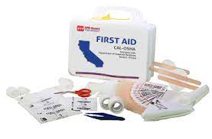

This is in addition to Individual First Aid Kits (IFAK) The size and makeup of your unit first kit will depend on the size and individual needs of the members of your unit. For a team kit, an OSHA Approved First Aid Kit for 15 employees is easily purchased and needs very little upgrading. This should be marked with the Team Name and Post number (if any)

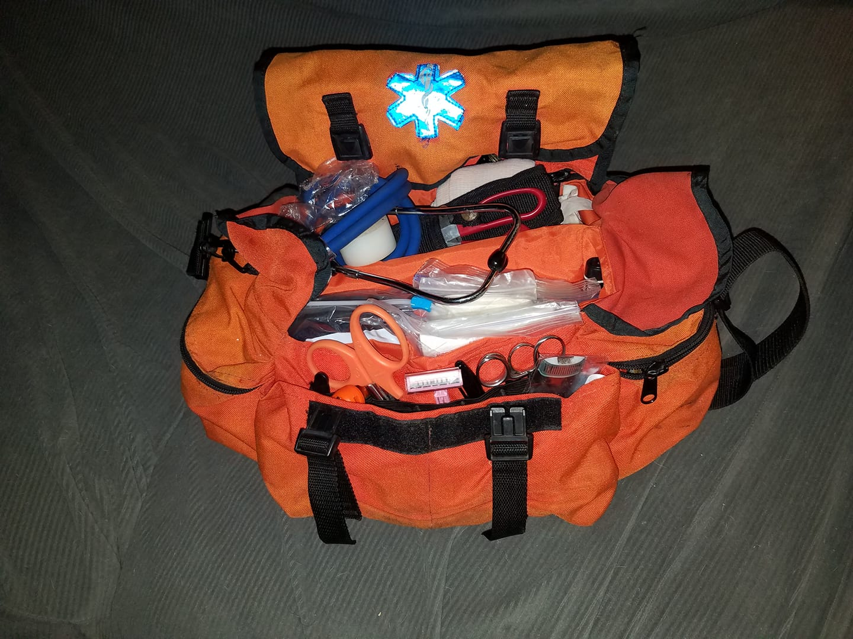The Unit First Aid Kit for a Post should be stored in a brightly colored cloth bag labeled as a first aid kit and marked with the Team and Post Number as well as USVR Prominently placed in permanent fashion. This can be done with the Unit Stencil.

***Unit Stencil:***

Each Unit should create a basic set of stencils for marking unit equipment, locations and even improvised uniform items in a pinch!

Stencil sets can be purchased at the hardware store. You want two sizes, a larger size and a smaller size set (Aprox. 3” large letter and 1” Small. To assemble, line up the letters in the desired configuration and then overlap each letter slightly and use masking tape to tape them to each other. Be careful not to cover the letter voids themselves! Then, Gently turn the assembled stencil over and do the same tape process to the other side. This will create a permanent stencil. Store them separately in a folder in the Unit Notebook. Each unit should at least have the stencils USVR in large and small lettering. These are required. Additional stencils can include Post Numbers, Team Name or other Identifying numbers and letters.

**Unit Shelters:**

* **Team Shelter**

On the Team level, a large tarp that can be set up as a lean to or fly to cover gear and people. This should be done with at least and 10x12 tarp. When you store the tarp, be sure to store rope, guy lines and improvised stakes so that you have everything you need to set it up.

* **Post Shelter:**

For Posts, the shelter requirement goes up a bit. Posts require the ability to set up a Field Command Post. This is a sheltered area where unit gear is stored and a table and chair or desk is set up for doing the business of running the post in the field. For this, a 10x10 popup shelter is the best choice, and the addition of walls are highly encouraged! The walls, and the edges of the roof should be marked with USVR stencils, Post numbers are also highly encouraged.

**Unit Gear Boxes**

* **Loaner Gear Box:**

This kit is designed to allow new members who may not have a ton of experience to have the kit they need. The box should include mess kits and utensils, extra bushcraft knives, flashlights, extra batteries, emergency space blankets and other non-perishable items that will get them through their first event. Make sure there is a can opener or two!

* **Safety Box:**

This box holds caution tape, Duck Tape, hammer, mallet or 1.5lb sledge hammer, an adjustable wrench, a machete with a sheath, leather work gloves and hard hats. Hard hats are marked USVR on each side. 3 hard hats is sufficient for loaning out to someone who does not ordinarily need one when they are in a hazardous area such as when a member of the public or media are present and such things as felling trees or security training might be happening.

* **5 Gallon Water Jug or Water Cooler:**

Hydration is important, each unit needs one of these. In a pinch, a collection of 2 liter soda bottles, properly cleaned can work. However, it is preferred that the unit retains a proper 5 gallon water carrier such as is used by construction crews. These must be marked with USVR and Post Number/Team Name

**Storage and Transport**

It is Highly encouraged that units standardize with good quality plastic totes. Craftsman makes them with Yellow and Red tops and these stack nicely, they also lock very effectively. The first aid bag can be stored in the safety box if there is room. Each tote should be marked with the appropriate title and a list of the contents should be kept at the top of each tote. Metal tools should be well maintained and put away oiled. A blast of WD 40 works fine. Cutting tools should be sharp and in good condition.

**Diagrams and Patterns:**

**Fig 1) Council Fire Layout**

**Fig 1A) Council Fire Layout**

**Fig 2) Bonnet Pattern**

**Fig 3) Chest Rig Pattern**

**Fig 4) Rifle and Shotgun Stand Pattern**

**Fig 5) Knife Sheath Pattern**

**Fig 6) Hunting Frock Pattern**

**Fig 7) Ideas for Tomahawk**