United States Volunteer Rangers
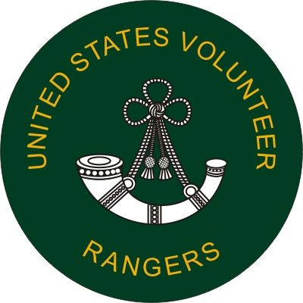
Membership Form

Name_____________________________Last Name______________________________ MI:_____

Mailing Address___________________________________________________

Phone Number____________________________

Email Address____________________________

State and Zone____________________________
SEX:
M___ F____

Name of Sponsor:_______________________________________________

Do you have any medical conditions that would effect your ability to participate in activities of USVR?
(Please include environmental and food allergies)
__________________________________________________________________________________________________________________________________________________________________________________________________________________________________________________________________________________________________________________________________________________________________________________________________________________________________________________________________________________________________________________

We have equipment and training requirements for many aspects of our mission and activities. Do you forsee any issue in obtaining these in a timely fashion?

Do you have any legal disabilities which would preclude you from participation in ANY activities of the USVR? (Note: These include the use of firearms and cutting tools as well as possession of said implements in my home, upon my person and within my vehicle)
Yes____ No_____

Page 2) CONSENT TO PARTICIPATE AND RELEASE LIABILITY EVENT: Name:______________________________ DATE: ________________________

I , the undersigned, do hereby state that I wish to participate in activities sponsored by the national organization New York Volunteer Rangers (hereafter "USVR") The USVR has rules which govern and may restrict the activities in which I can participate. These rules include, but are not limited to: Corpora, the by-laws, the various state and chapter laws rules and regulations and the individual unit SOPs, The USVR makes no representations or claims as to the condition or safety of land, structures or surroundings, whether or not owned, leased, operated or maintained by the USVR. I understand that all activities are VOLUNTARY and that I do not have to participate unless I choose to do so. I understand that these activities are potentially dangerous or harmful to my person or property, that due to the mission requirements of the USVR, If I deploy, I may find myself in disaster areas and that by participating I voluntarily accept and assume the risk of injury to myself or damage to my property. I understand that the USVR does NOT provide any insurance coverage for my person or my property. I acknowledge that I am responsible for my safety and my own health care needs, and for the protection of my property. And that In exchange for allowing me to participate in these USVR activities and events, I agree to release from liability, agree to indemnify, and hold harmless the USVR and any USVR agent, officer, or USVR employee acting within the scope of their duties, for any injury to my person or damage to my property. This Release shall be binding on myself, successors in interest, and/or any person(s) suing on my behalf. I have read the statements in this document. I agree with its terms and have voluntarily signed it. I understand that this document is complete unto itself and that any oral promises or representations made to me concerning this document and/or its terms are not binding upon the USVR, its officers, agents and/or employees.
I further agree to abide by the Code of Conduct of the USVR and understand that my continued membership relies on my adherence to said code.
I UNDERSTAND THAT THIS IS A LEGAL DOCUMENT. I HAVEREAD AND UNDERSTOOD THIS RELEASE AND I UNDERSTAND ALL ITS TERMS. I EXECUTE IT VOLUNTARILY AND WITH FULL KNOWLEDGE OF ITS MEANING AND SIGNIFICANCE.

LEGAL NAME (PRINT)_____________________________________

LEGAL NAME (SIGN) __________________________________

